A4058-Asia-Persia-Luristan-Capped, Bearded, Warrior God with Tunic and Sword-Bronze-900-700 BCE

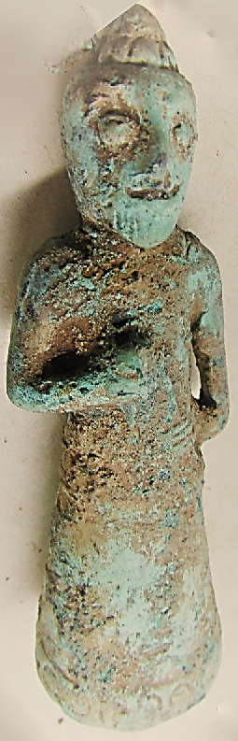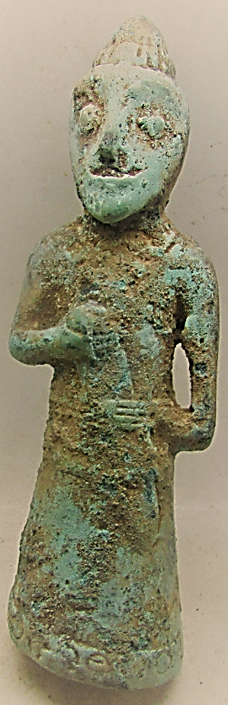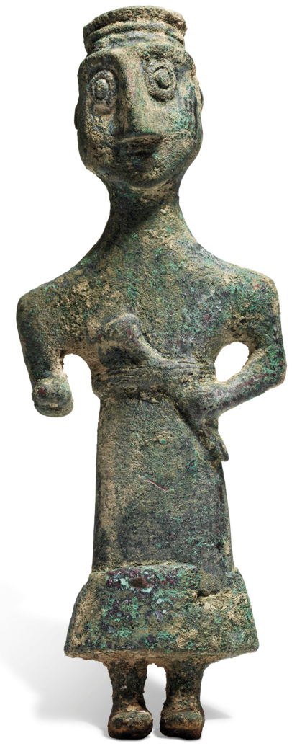

Figs. 1-2 A000-Asia-Persia-Luristan-Bearded Warrior God-Tunic-Sword-Bronze-900-700 BCE

Fig 3. A000-Asia-Persia-Luristan-Bearded Warrior God-Tunic-Sword-Bronze-900-700 BCE

Christies-2018 Lot 72.

**Case no.: 4**

**Accession Number:**

**Formal Label:** Asia-Persia-Luristan-Bearded Warrior God-Tunic-Sword-Bronze-900-700 BCE

**Display Description:**

**LC Classification:**

**Date or Time Horizon:**

**Geographical Area:**

**Map:**

**GPS coordinates:**

**Cultural Affiliation:**

**Media:** **Dimensions:**

**Weight:**

**Condition:**

**Provenance:**

**Discussion:**

**References:**

